**SUM OF CUBE:**

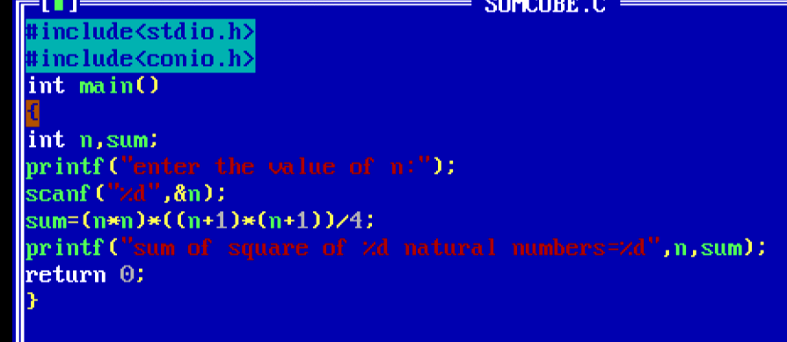

**OUTPUT:**

